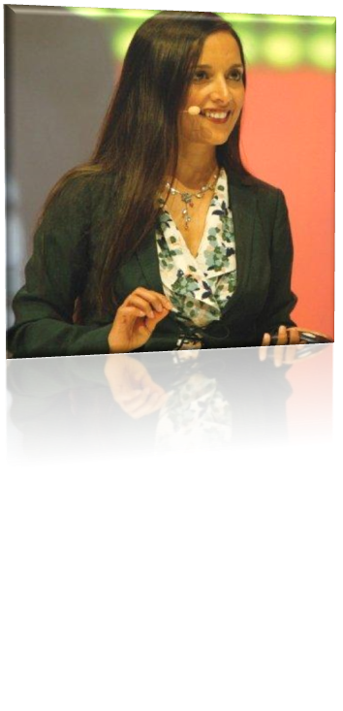

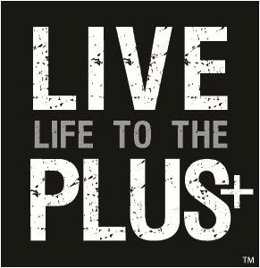

Beauty & the Brain

DR. MITRA RAY
Author of Simple and Delicious Recipes for Vitality,
Do You Have the Guts to be Beautiful, and From Here to Longevity

Join us for a dynamic & intimate presentation that will provide answers regarding diet and nutrition.

*Develop new strategies to look and feel your best!
*How the brain functions with proper nutrition.

*How to protect yourself at the molecular and cellular level.

*Learn about the power of nutrition through the ages

What others have said about her books, seminars and retreats:

"Mitra Ray's book is unique and very useful." Deepak Chopra
"A must-read for expecting mothers and parents."
“This book will also help grandparents age healthfully." Dr. William Sears
"I admire Dr. Ray's work and enthusiasm." T. Colin Campbell, Author of The China Study

Opportunity to hear Dr. Ray
Date: Thursday, May 31st 2012
Doors Open 7pm: Start: 7:30pm
Monte Carlo Inns (Savoy Event Venue)
7255 Warden Ave, Markham Ontario L3N 1B4
(3 minutes south on Warden/407)

RSVP: Nicole Scott 416-427-5080 www.passionfornutrition.ca
www.drmitraray.com

